**Website Project Proposal**

CU-Online Exam Console (Beta)

**COMSATS University Islamabad**

Sahiwal Campus



**Usama Sarwar**

FA17-BS(CS)-090-B

**Waheed Ramay**

Web Development

May 18, 2020

Table of Contents

1. Introduction 1

2. Executive Summary 1

3. Solution Outline 1

4. Modules 2

4.1 Home Screen containing categories of exams 2

4.2 Exam Screen 2

4.3 Result Screen 3

4.4 Answers Screen 3

5. Site Integrations 4

6. Additional Features 4

6.1 Android App (Flutter App) 4

6.2 iOS App (Flutter App) 5

7. Tools and Technology 5

8. Execution Timeline 6

9. Conclusion 6

List of Figures

Figure 1. Home Screen 2

Figure 2. Quiz Screen 2

Figure 3. Result Screen 3

Figure 4. Exam Solution Screen 3

Figure 5. Pixel 2 (Preview) 4

Figure 6. iPhone X (Preview) 5

# Introduction

COMSATS University Islamabad is the top ranked university in Computer Science Department around the country. It has its own content management system named as CU-Online. I’m a student of Computer Science Department at COMSATS University Islamabad contributing in the development of CU-Online system by developing an online Examination System. The teacher creates a quiz/exam. In such an exam system instructor can create questions and add them to the exam. Teacher can choose between multiple choice questions or True/False Questions. The students are provided with a link to the online exam, they sign up and can take the exam. They see the results immediately afterwards. The big benefit of online examination is the cost and time saving, both for students and teachers. The biggest limitation is that you have to be online to use an online examination system. Hence the name "online". Everybody who needs an exam to be taken by a group of students. Users for this project may range from schools and teachers to companies. Obviously, it must be possible to create an exam, and add questions. Preferably the exam provides for the option to create a question bank and you have to be able to set the rules for when a student passes or fails the exam.

# Executive Summary

Online examination is conducting a test online to measure the knowledge of the participants on a given topic. The big benefit of online examination is the cost and time saving, both for students and teachers. The biggest limitation is that you have to be online to use an online examination system. This system can be used by Schools, teachers and companies.

# Solution Outline

Many universities are switching to online exams during COVID-19. For one, Oxbridge’s summer assessments are moving online. Over at Imperial College London, 280 medical students successfully completed final-year exams last week. The university says this a historic first for medical studies. Online exams during COVID-19 shows benefits of digital assessment. Online or digital exams can save lecturers ample marking time. It also saves students the hassle of putting pen to paper to demonstrate their knowledge in an area of study. According to the University of Technology Sydney, students are also less anxious about online exams as they can first do practice tests online. This assessment model also explores the possibility of automated marking for standardized tests.

# Modules

The website will have the following modules:

## Home Screen containing categories of exams

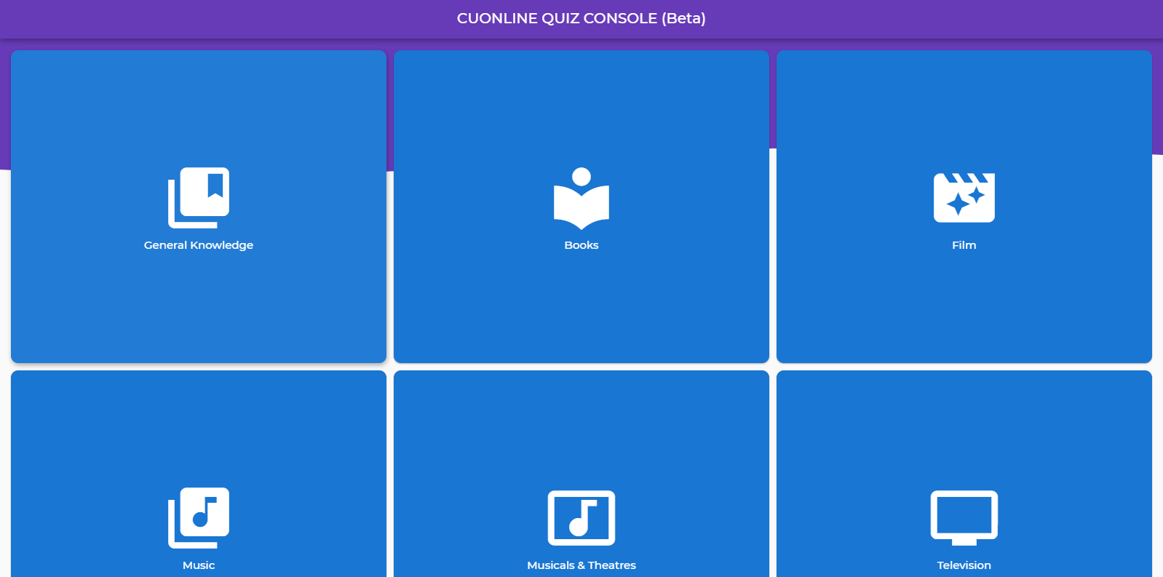

Figure 1. Home Screen

## Exam Screen

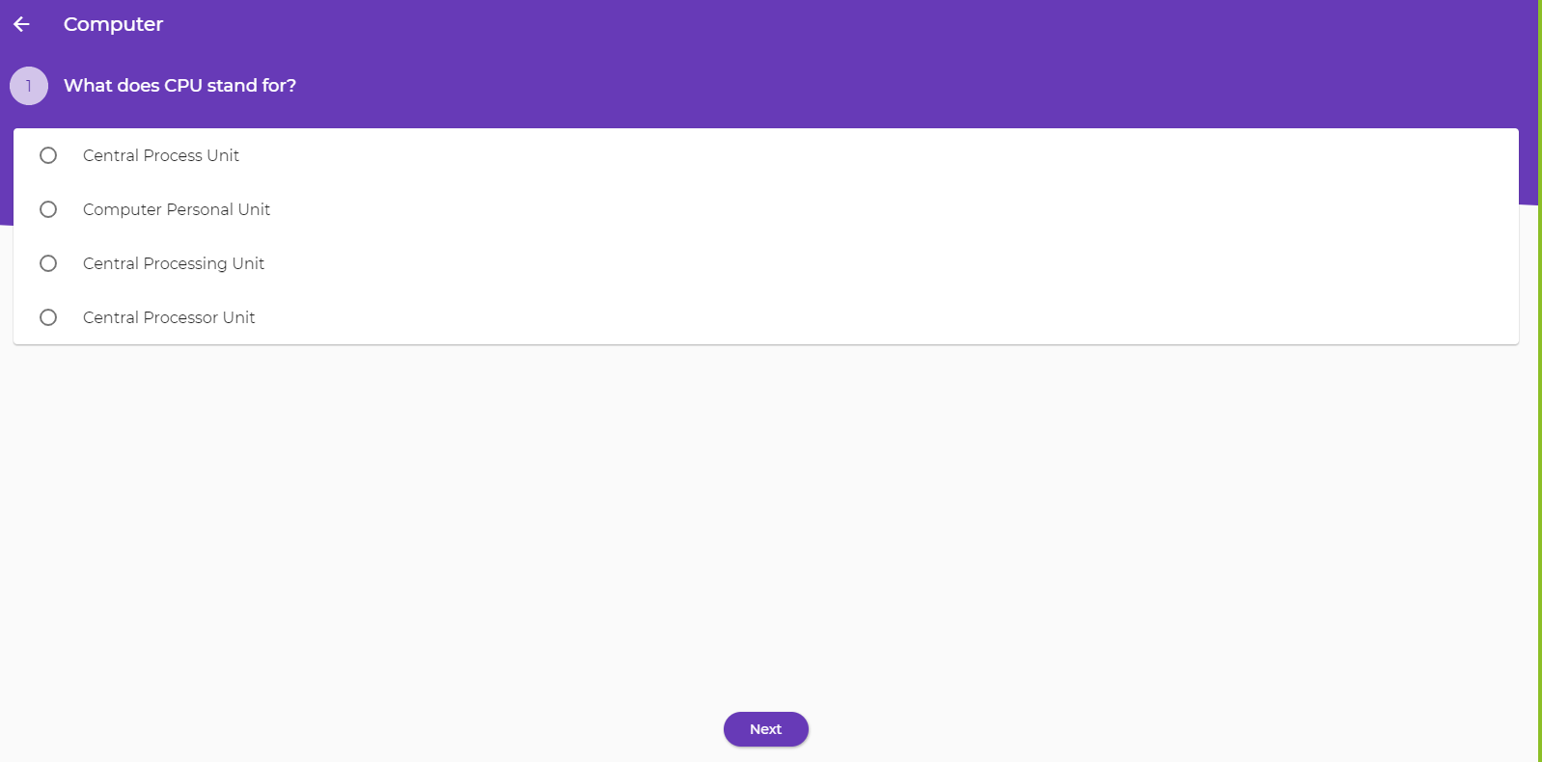

Figure 2. Quiz Screen

## Result Screen

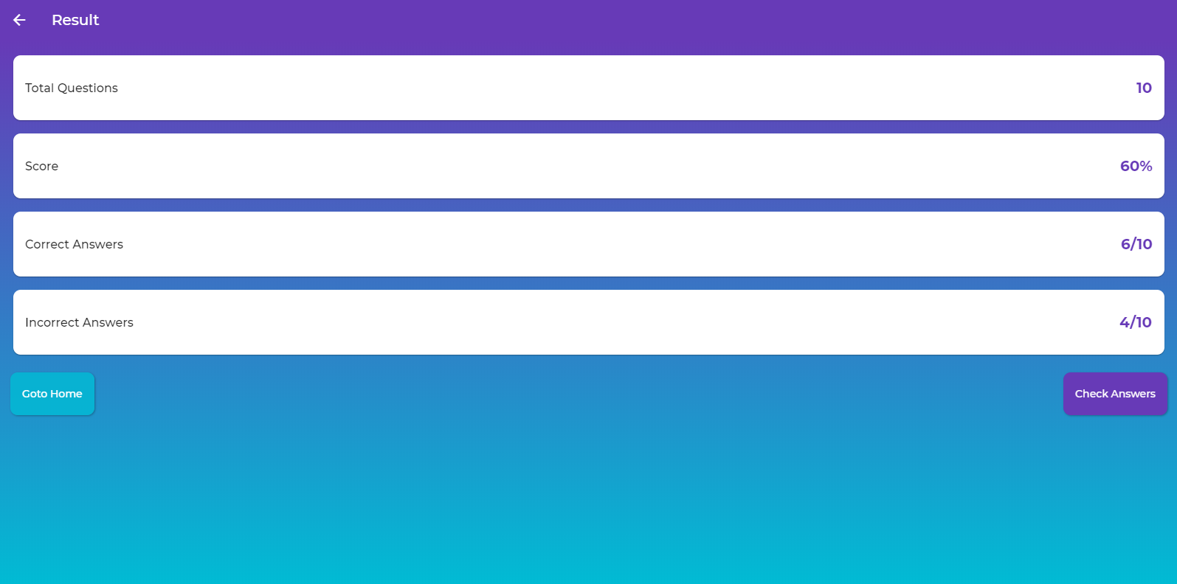

Figure 3. Result Screen

## Answers Screen

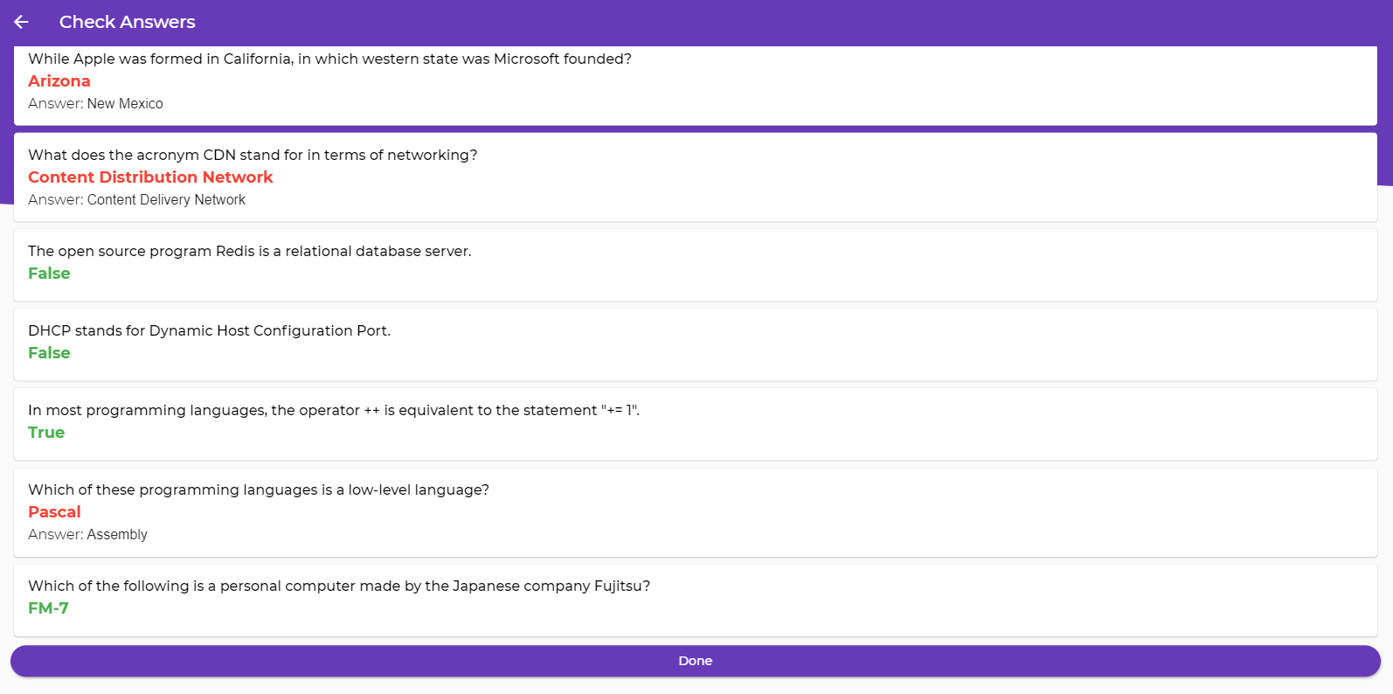

Figure 4. Exam Solution Screen

# Site Integrations

This website is integrated with the following tools:

* Analytics: To check the usage analysis of website
* CRM: Content/Exam Management

These integrations will allow you to use your website as a useful exam conducting tool which helps you to check and pass the students.

# Additional Features

Based on previous discussions regarding the goals and expectations, this website will have the following additional features:

* Instant Result
* Instant Answers of the Exam after the exam is completed

## Android App (Flutter App)

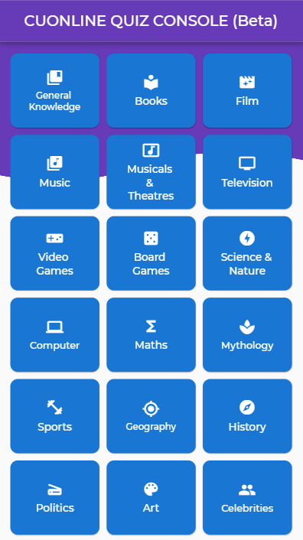

Figure 5. Pixel 2 (Preview)

## iOS App (Flutter App)

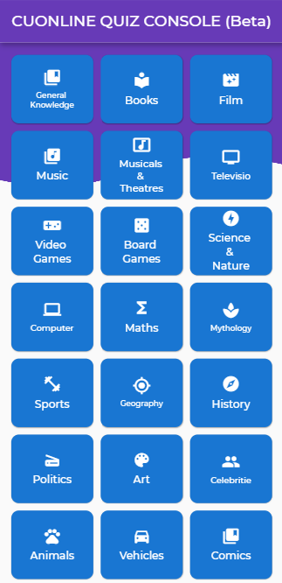

Figure 6. iPhone X (Preview)

# Tools and Technology

* Programming Language: Flutter Web
* Visual Studio Code
* Chrome Browser
* Kotlin Support for Android Platform
* Swift Support for iOS Platform

# Execution Timeline

The following table details our projected execution timeline for project.

|  |  |
| --- | --- |
| Stage | Completion Date |
| Project Kickoff Meeting | April 15, 2020 |
| Initial Design Wireframe | April 20, 2020 |
| Page Mockups | April 25, 2020 |
| Site Copy & Images | May 01, 2020 |
| Functional Prototype | May 18, 2020 |
| Website Development Complete | June 18, 2020 |
| Testing | June 22, 2020 |
| Website Launch | July 01, 2020 |

# Conclusion

In this way this website will be used for conducting online exams at COMSATS University Islamabad. This website is developed with Flutter. That’s why there will be generated Android and iOS App that will perform the same function with enhanced platform support.